**PRINCE DR K VASUDEVAN COLLEGE OF ENGINEERING AND TECNOLOGY**

**Mambakkam - Medavakkam Main Rd, Ponmar, Chennai, Tamil Nadu 600127**

DEPARTMENT OF COMPUTER SCIENCE AND ENGINEERING.

IOT(INTERNET OF THINGS) **ASSIGNMENT 2**

**IOT BASED SAFETY GADGET FOR CHILD SAFETY MONITORING AND NOTIFICATON**

**TOPIC** : Build a python code,assume u get temperature and humidity

values(generated with random functions to a variable) and

write a condition to continuously detect alaram in case of high

temperature

**NAME** : Jayashree.S

# CODE:

**OUTPUT:**

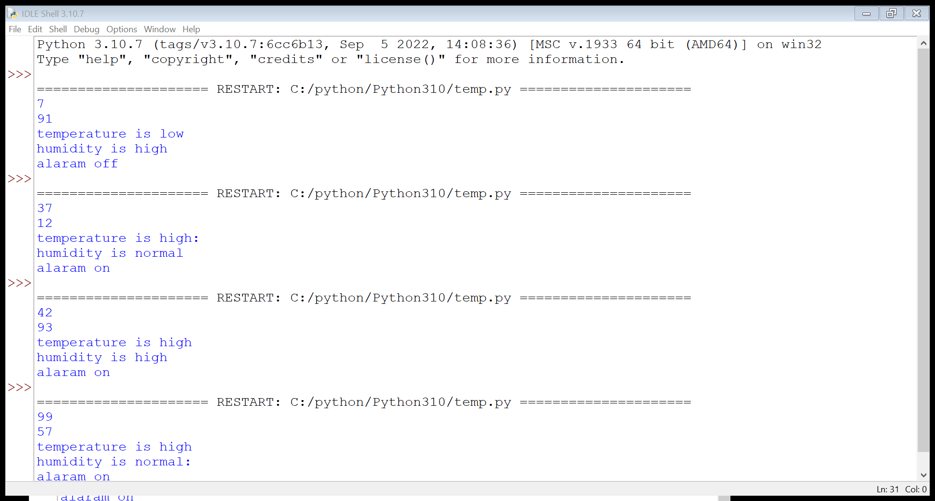

**FEGURE 1**: python code, to get temperature and humidity values.

******************************THANKING YOU***********************************